Exercise 1: Implementing the Singleton Pattern
Logger class
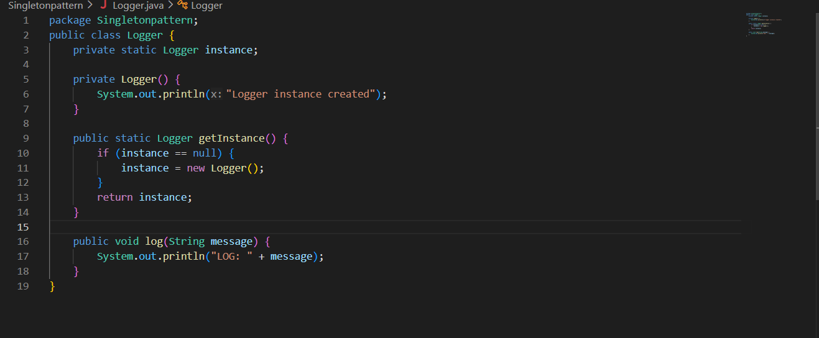
Test logger and output
